**Generator on virtual cathode (VCO)**

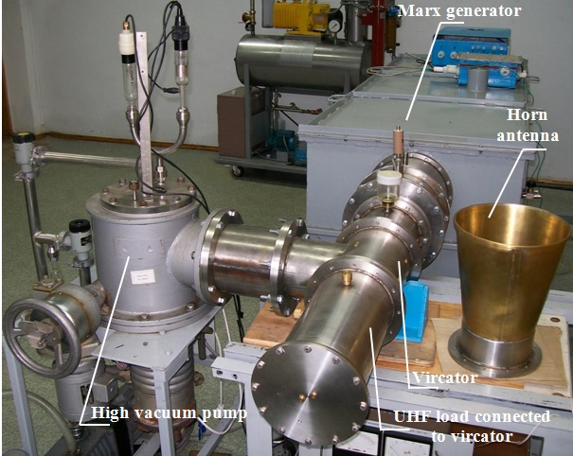

Generator on virtual cathode (VCO) is a know-how equipment specifically designed for studies of electro-magnetic compatibility of various electronics used in construction of complicated hi-tech objects like airports, control stations of electric power plants, space launch sites, etc.

**Brief technical description**

**Vircator and its modifications**

***Generator on virtual cathode (vircator)***

Unlike other types of generators, generators on virtual cathode (vircator-VCO) – is quite recent type of relativistic electronics generators. In VCO for generation of RF the energy of fields created by relativistic electron beams is used. These beams are injected into electro-dynamic structure in super-critical currents mode. In this mode at injection of high current relativistic electron beam (REB) into electrodynamic structure, with current value higher than critical for this particular structure, the space charge or how we call it *virtual cathode* emerges in this structure.

At that, we can witness electrons flow, reflected from virtual cathode and moving towards injected beam. As a result, oscillating reflected electrons, beam electrons and virtual cathode electrons excite electromagnetic waves within electrodynamic structure.

Value of critical current is determined by geometry of electrodynamic structure. In case of injection of solid cylindrical beam with radius *rb* into round shape waveguide with radius *R* at *rb* *˂ R* this values is determined by the following equation:



(1)

where: *m, e* – mass and charge of electron; *R* – radius of cylindrical electrodynamic structure; *rb –* radius of electron beam; - relativistic factor.



- velocity of electrons; *c* – velocity of light.

For cases, when ring-type electron beam is injected with ring diameter ∆, critical current value is determined by the equation:



(2)

From correlation (4) and (5) we can see that for certain geometry of electrodynamic structure and electrons value the figure *I0* is increasing with increase of energy of electrons of injected beam, current and power values of injected beam are also increasing.

This means that simultaneously with increasing the value of radiated power, the efficiency is also increasing proportionally, that leads to further increase of RF power. This fact allows to state that VCO belongs to the class of most powerful relativistic generators.

Availability of three groups of electrons in electrodynamic structure (electrons of injected beam, electrons of virtual cathode and reflected electrons), each of them having wide band of velocities, leads to wide band of RF. This fact allows to determine VCO as a wide band relativistic generators.

Due to these two basic characteristics – high value of pulse power (up to 1010 Watt) and wide radiated band – all research activities with VCO initially were dedicated to achieving record level values of radiated power and radiation duration (energy in pulse).

At a later stage more in-depth R&Ds were dedicated to this generator, in particular to study possibility of spectrum control, phase-locking of VCOs, combining VCO with other relativistic devices (virtod), etc.

In the process of such R&D studies great variety of VCO modifications were developed and experimented with. However, all this variety could be divided into two major types:

**- reflecting triode with virtual cathode;**

**- VCO with drift beam.**

Engineering options in development of these two types are multiple.

***Reflecting triode with virtual cathode***

Sketch of design of reflecting triode with virtual cathode could be seen below at Drg. 1.

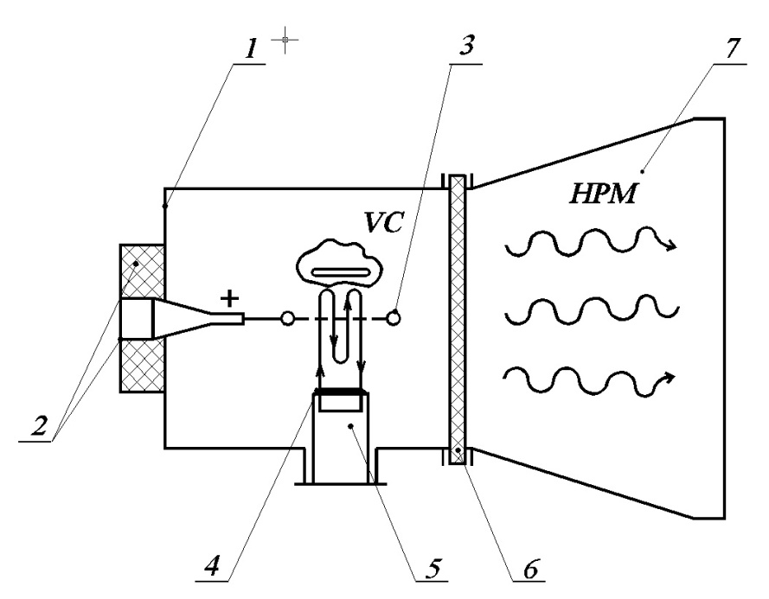

**Drg. 1. Sketch of reflecting triode with virtual cathode**

1- sealed-off electrodynamic structure; 2- connection to power supply source; 3- grid type anode with transparency level 0.5÷0.9; 4- emitting surface of cathode; 5- cathode hold; 6- output dielectric window; 7- horn antenna.

This type of generators operates as follows. At supply of positive voltage pulse amplitude 300 – 1000 KV to grid anode (3) through connection point (2), electrons beam from emitting surface (4) and current *I* higher that critical current *I0* is accelerated within gap cathode-anode and passes through grid cathode to the space behind it, creating virtual cathode (VC). At this point electron beam is braking by its own Coulomb field of space charge and reflecting back to anode (3). Distance from VC is close to distance between anode and real cathode (4). Electrons, reflected from VC, are passing through grid anode (3) and drifting to real cathode (4), where they are again breaking and reflected back.

Thus, could of electrons close to grid anode is created. These electrons are oscillating in potential pit, created by real and virtual cathode. Part of them is condensing on anode grid, however loss of these particles is compensated by new electrons, coming from cathode in correspondence with relativistic law Child-Langmuir (law 3/2).

This system of oscillating electrons is exiting in electrodynamic structure (1) electromagnetic fields at oscillation frequencies or multiple to them. Such interaction is accompanied by auto-modulation and development of electron bunches, effectively interacting with their own modes in electrodynamic structure. This process is accompanied by effective microwave radiation through output dielectric window (6) and horn antenna (7).

Frequency of generated radiation is determined by anode-cathode gap and applied voltage. Its value is calculated taking into account relativistic corrections by half-empiric equation:



(3)

where: - relativistic factor of electrons at input into contact space; *V0 –* accelerating voltage; *d* – gap value “cathode-anode”;  - function with value between 1 to 1.5 at changes 1 to ∞.

It is seen that frequency of generated radiation without changes of geometry could alter within wide limits by changing power supply voltage.

Described type VCOs normally operates in centimeter and decimeter band with quite high efficiency up to 10%, that allows to receive at output radiated power value (1÷3)∙109 Watt. Electrodynamic structures of such VCO are normally longer that wave length, thus overall dimensions of VCOs are quite big.

***VCO with drift beam***

Sketch of design of VCO with drift beam could be seen below at Drg. 2.

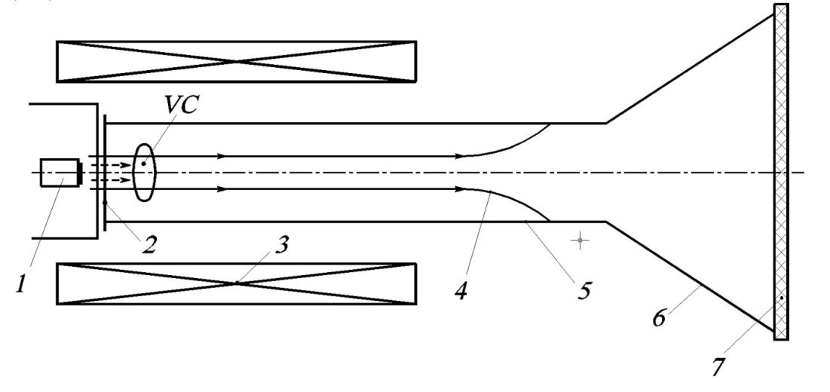

**Drg. 2. Sketch of VCO with drift beam**

1- cathode; 2- anode; 3- solenoid for magnetic field creation; 4- trajectory of beam particles; 5- electrodynamic structure (cylindrical waveguide); 6- horn antenna; 7- output dielectric window.

This type VCO operates as follows: electron beam at supply of high voltage is shaped inside cathode-anode gap (1)-(2) and through anode grid with transparency level 0.5 ÷ 0.9 is injected into electrodynamic structure (cylindrical waveguide). In case current value of injected beam is more than critical for such geometry, virtual cathode (VC) is emerging. Part of electrons is reflected and drifts back to cathode and after that start oscillating. Other part of electrons after passing through VC is drifting (4) inside cylindrical waveguide (5), and at the end of drift meeting the walls of structure. Distance between VC and anode grid, reflected and passed part of electrons proportions depend upon amplitude of voltage pulse, supplied to anode-cathode gap (1)-(2).

Generation in this type of devices takes place due to the following main mechanisms: due to oscillation of particles around anode grid and due to self-oscillations of virtual cathode. In this case oscillating electrons interact with modes of electrodynamic structure.

There are several modifications of VCOs of this type, different in dimensions and availability or absence of magnetic field. Availability of magnetic field allows to increase conditions of electron beam delivery and, respectively, to control quantity of electrons and their density within virtual cathode as well as quantity of oscillating electrons in gap cathode-anode. As soon as these values effect radiation spectrum, by application of external magnetic field it is possible to control radiation spectrum of this type VCO.

As we have noted before, parameters of VCOs of both the types are dependent upon not only their geometry / dimensions, but also current of electron beam and energy of particles within. From the other side, this opens way for control of radiation spectrum and radiation power. Simultaneously, this applies quite strict requirements to shaping and stability of power supply pulses that is a complicated task.

In order to address this problem, studies were conducted to control output parameters of VCOs by means of feedback coupling through high frequency field.

This approach opens possibility to control VCO allowing to achieve either narrow band radiation spectrum, or continuous wide band, or switch VCO to stochastic oscillations mode. VCOs with external feedback coupling are called virtodes.

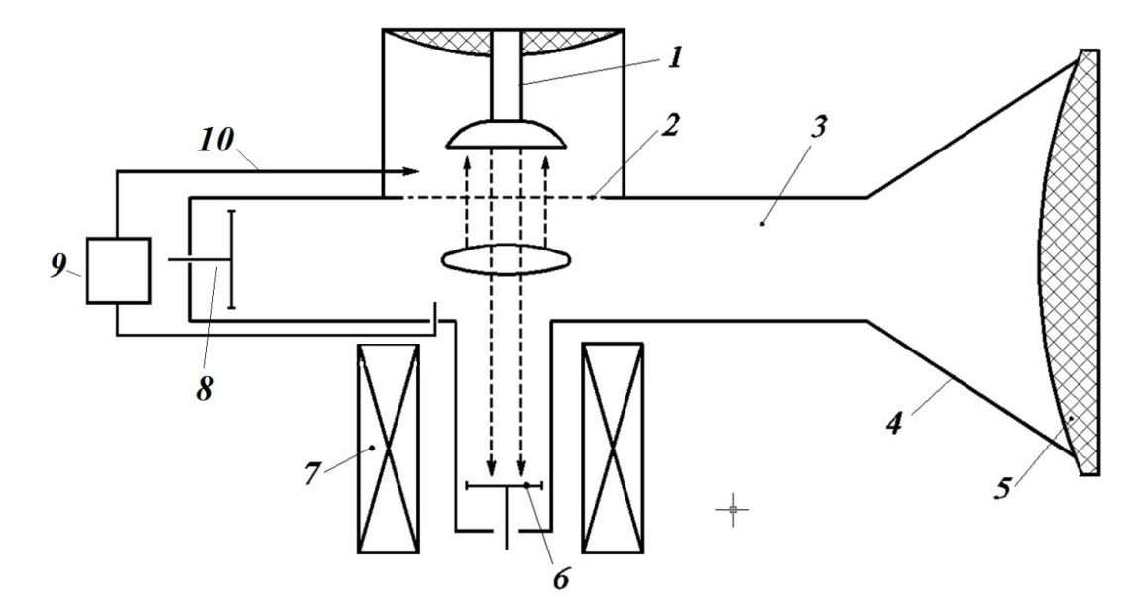

**Drg. 3.** **Sketch of virtode**

1 - cathode; 2 – anode grid; 3 – electrodynamic structure (waveguide); 4 – horn antenna; 5 – dielectric lens; 6 – electron beam current collector; 7 – solenoid for magnetic field generation; 8 – short circuit plunge (piston); 9 – phase shifter in feedback coupling circuit (10).

In virtode structure electron beam, shaped in gap between cathode (1) – anode (2) is drifting through waveguide (3) perpendicular to traveling wave of basic mode of waveguide (for rectangular waveguide – mode H01). At that, part of energy of generated radiation (around 15%) by feedback coupling (10) is delivered to anode-cathode gap. Simultaneously, optimal conditions of device stabilizing are maintained.

Phase in feedback circuit (10) is controlled by phase shifter (9). Maximum of generated E-field wave is shaped by plunge (8).

As a result, electron beam injected into waveguide (3) becomes modulated on virtual cathode oscillation frequency.

This scheme implements “fast” feedback with typical reaction time:



(7)

where: - typical reaction time; *f –* operating frequency; *P0* – power of generated signal; *Pcont –* power of control signal that has passed feedback coupling line.

This opens wide possibilities for creation of phase arrays.

Experimentally proven output power of such devices is 600 MWatt and efficiency – 0.03 ÷ 0.17 depending upon radiated spectrum shape.

**To summarize, our theoretical and experimental works on laboratory VCOs of different types proves that currently it is possible to develop devices with the following basic characteristics:**

**- operating frequency band – 2-10GHz;**

**- electronic shifting of mean frequency – 10-15%;**

**- efficiency – 8-10%;**

**- peak power level – 105 ÷ 109Watt;**

**- PRF – up to 102Hz.**

This allows to utilize potential of PRF modes  ≈7∙108 W/m2 and single pulse mode ≈3∙107 W/m2.

Due to wide band character and limited level of generated power, spectrum density of power of VCOs is not significant. This makes them very safe in operation for laboratory studies of electro-magnetic compatibility of electronic equipment.